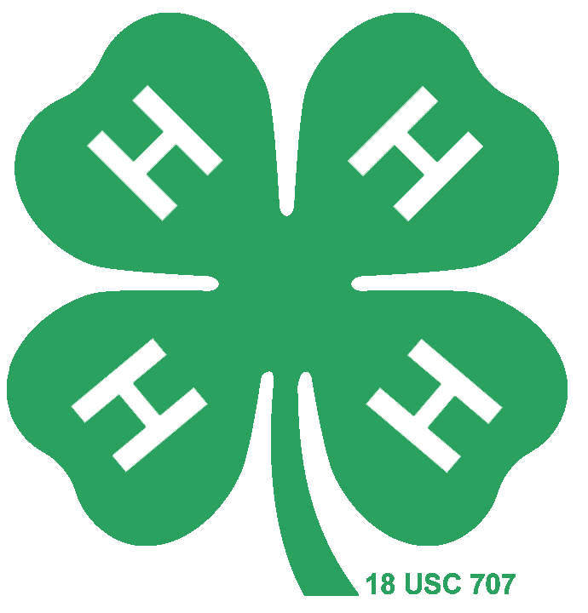
Premier Exhibitor
Horse Study Guide

4-H Horse Project- Colorado State University Extension
Colorado 4-H Horse Show Rulebook 2018 (Questions 21-25)
- Breeds
- Color & Markings- Body Colors
- Teeth & Determining a Horse’s Age
- Pre-Purchase Exam
- Grooming-Hoof Care
- Feeding & Nutrition- Anatomy and Physiology of the Digestive Tract
- Feeding & Nutrition- Anatomy and Physiology of the Digestive Tract
- Riding Aids, Gaits, and Lateral Work- Body Position and Aids in Motion
- Western Tack and Equipment- Bridle
- Health Problems & Diseases-Colic
- Horse Judging
- Riding Aids, Gaits, and Lateral Work-Lateral Movements
- Feeding & Nutrition- Types of Feed
- General Health-Vital Signs
- Feeding & Nutrition- Hay
- Housing and Fencing-Fencing
- Health Problems and Diseases- West Nile
- Body Positions and Aids In Motion- Posting or Rising Trot
- Body Position and Aids In Motion- The Correct Lead
- Basic Handling and Safety- Leading
- Description of Body Condition Score System
- Reproduction- Breeding
- Reproduction-New Foal Care
- English Tack & Equipment
- Health Problems and Diseases
- Parasites
- Ranch Horse Discipline- Cow Work
- Individual Events- Barrel Race (Colorado 4-H Horse Show Rulebook 2018)
- Western Riding (Colorado 4-H Horse Show Rulebook 2018)
- Hunter Hack (Colorado 4-H Horse Show Rulebook 2018)

