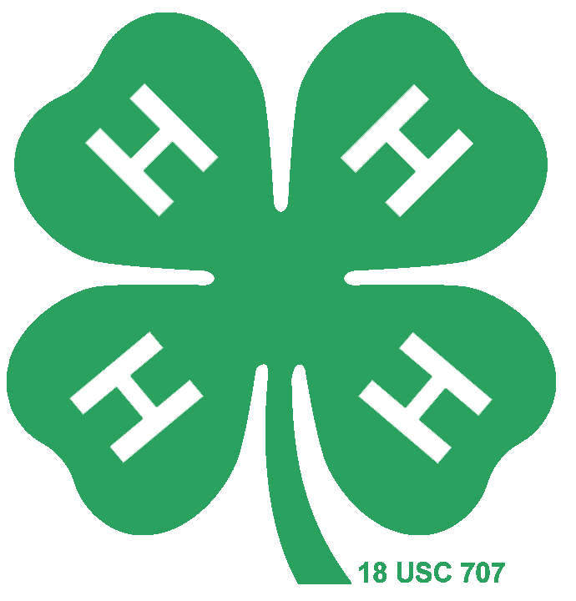
Premier Exhibitor
Miniature Horse Study Guide

4-H Small Equine Ohio State University

- Miniature Horses and Other Small Equine- Miniature Horses
- Miniature Horses and Other Small Equine- Miniature Horses
- Miniature Horses and Other Small Equine- Miniature Horses
- Miniature Horses and Other Small Equine- Miniature Donkeys
- Miniature Horses and Other Small Equine- Miniature Mules & Hinnies
- Breeds and Conformation- Breed Types
- Breeds and Conformation- Conformation
- Health Care- Health
- Health Care- Health
- Health Care- Health
- Health Care- Health
- Health Care- Health
- Health Care- Common Health Issues
- Nutrition- Assessing Body Condition and Weight
- Nutrition- Nutritional Requirements
- Nutrition- Nutritional Requirements
- Nutrition- Forage
- Competition
- Competition
- Competition

