You have decided to reduce your need for water by removing some or all of your lawn so that you can replace it with something that is more water-wise. But how do you go about doing that in the most economically and ecologically smart way?
Considerations:
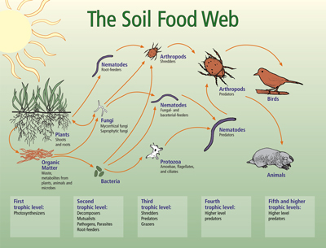
- Maintain soil structure – Good soil structure allows for oxygen and water to get to the roots of your plants.
- Maintain soil microbiology – Some bacteria and fungi in the soil decompose large organic molecules into smaller particles that are more available for plants. Some can increase the moisture holding capacity and the heat tolerance of the plants. (Click USDA – Soil Food Web diagram for more information about the importance of the soil microbiome.)
- Protect above-ground insects & wildlife (and human health) – Some people are concerned about the impact of herbicides on bees and other pollinators as well as the reports about cancer-causing ingredients. (Click here to read more from Yale’s e360 about the impacts of herbicides on honeybees. Click here for a recent paper from Tufts University on diverging conclusions about the safety of glyphosate-based herbicides: “scientific conclusions are all over the map.”)
- Ease of use – Is heavy machinery involved? Are you physically capable of using it? Do you have to rent it?
- Expense
- Length of time to remove turf
What are the options for removing turfgrass?
No method exists that satisfies all considerations listed above.
Spray with a non-selective herbicide, e.g., Glyphosate – This method is a relatively fast, cheap and easy way to kill your lawn. It maintains the soil’s structure and microbiology and leaves the organic content (dead grass and roots) in place to decompose. Because you are not disturbing the soil, weed seeds are not brought to the surface to germinate. You may need to apply the herbicide 2-3 times, 2-3 weeks apart. See the articles linked about to decide if you are comfortable with the health and ecological (possible) risks. READ AND FOLLOW THE LABEL INSTRUCTIONS for safe application.
Solarize – Water thoroughly and cover the area you want to kill with clear plastic, making sure that the edges are sealed. Leave it there for 4-8 weeks. This method is most effective in the hottest months from June through August. It is not aesthetically pleasing and may invite complaints from the neighbors, but it is a low-effort option. Leave the dead grass or rake it up. Avoid disturbing the weed seed bank by not tilling it in. Research has shown that there is only a temporary reduction in soil microbial activity.
Mow close and cover – Withhold water from the area to stress the grass. Scalp it by mowing it as close as possible. Then cover the area with compost and an 8-12” layer of woodchips. Water well to encourage decomposition. Many gardening sites recommend using layers of newspaper or overlapping pieces of cardboard. This will slow down an already lengthy process, and it temporarily reduces soil microbial activity which is important for soil and plant health. Be aware that this will take a season or more and still may not kill all of the bluegrass.
Dig it up – Water the area thoroughly to soften the soil. Dig up the grass, thatch and roots. Then cover with soil and mulch. This method is a quick solution, depending on the size of the area, and it allows you to plant immediately. However, it is difficult work, and you are removing the organic material that would be beneficial for the soil and the plants. It also disturbs the soil’s structure and brings weed seeds to the surface where the warmth and moisture germinate them.
Till it under – Till 24 hours after rain when the soil is warm and damp. Start with a shallow setting to slice the sod, using increasing depths to break up the clods of grass, soil, and roots. It is best to till in the fall when the grass can return nitrogen to the soil. In the spring, grass and weeds may regrow as the weather gets warmer. A tiller can be heavy, noisy, and smelly, but your hard work is rewarded with a garden that you can plant immediately. This method does destroy soil structure and can propagate weeds like bindweed and Canada thistle.
Use a sod cutter – If your lawn is in good condition, you can cut strips with a sod cutter, roll them up and give them away. First, mow and water your lawn. Cut overlapping strips of sod and roll them up. Cut strips short enough to be moved easily. This method is quick but requires heavy equipment and you are left with the dilemma of how to get rid of the rolls of sod. Alternatively, you can flip the sod over to decompose in place, keeping the organic matter in your yard or garden. You then treat it like the ‘mow and cover’ method. Cover with compost and mulch and water to promote decomposition.

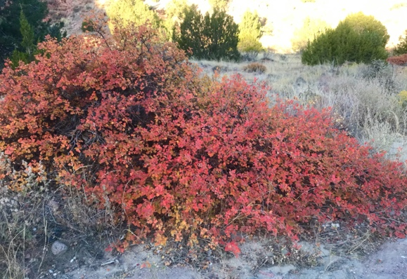
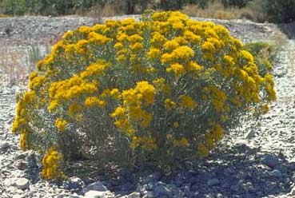
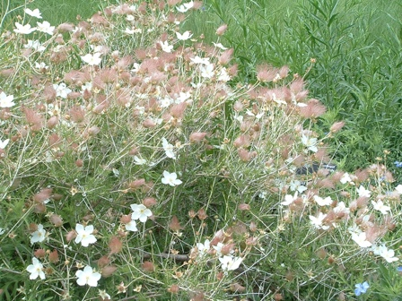
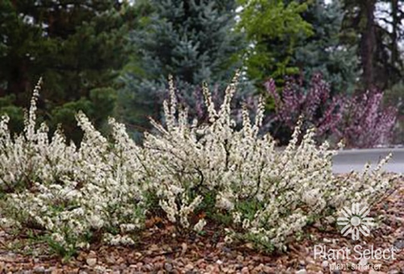
Stress the lawn & plant native shrubs – Mow the lawn very short and stop watering your lawn to drought-stress it. Plant native shrubs close enough together so that the mature size will create a continuous cover of shrubs. Water only the shrubs (not your lawn). As they grow bigger, they will provide shade to inhibit lawn growth underneath as well as provide food and shelter for birds and other wildlife. Some excellent, large, drought-tolerant native shrubs that will provide ecological value and winter interest are Three-leaf sumac (Rhus trilobata), Apache Plume (Fallugia paradoxa), Pawnee Buttes Sand Cherry (Prunus besseyi), and Rabbit brush (Ericameria nauseosa).
Rhus trilobata - Photo by Irene Shonle
Ericameria nauseosa – Photo by Utah State University Extension
Fallugia paradoza – photo by Irene Shonle
Prunus besseyi - Photo by Plant Select

Where do I start?
The amount of labor required to remove your lawn may be overwhelming, but don’t let that deter you. You do not have to do it all at once. Begin with the odd areas that are difficult to mow, such as slopes, tight corners and small patches between sidewalks or driveways. Sections of your lawn that always seem to be in poor condition are prime candidates for removal. You may also want to start with the edges of your property and work in from there, creating beautiful low-water gardens that replace thirsty bluegrass lawns.
Wherever you decide to begin and whatever method you choose, you will be helping the environment, the water supply, and your pocketbook.

