Native plant LIST

A Companion to “How to Remove Your Lawn” Fact Sheet

Why Plant Natives?
Because native plants are naturally adapted to our lean soils and dry climate, they require fewer soil amendments, less fertilizer, and less water than non-native plants. Once they are established, native plants require little supplemental irrigation. They can also be more pest and disease-resistant when planted in a landscape that replicates their native environment. By planting native trees, shrubs, and perennials, you will be helping to restore habitat, providing food, shelter and other important resources for insects, birds, and mammals.

How to Plant a Native Garden
Soil Preparation – Native plants do not necessarily require amended soils. In our urban landscape, soils can become extremely compacted or have been scraped off for construction. In that case, using a garden fork to loosen the soil 1-2 feet deep may be necessary to create the drainage and water/oxygen-holding capacity. Adding organic matter can also improve tilth, or nutrient-holding capability. Doing a soil test is the best way to determine what your soil needs to support natives.

If you have clay soil, choose natives that tolerate clay or build berms 8-24” high to create the well-drained soil above the undesirable clay. Kelly Grummons, horticulture consultant and nursery owner, provides a recipe for amending clay soils: To 70% clay soil, add 10% wood-based compost and 20% small aggregate or crusher fines. Incorporate well.

Water – Even drought-resistant plants need additional water to establish a deep root system in their first year, especially the first few weeks. Small roots are susceptible to drying out. Then water when the soil is dry to a depth of 2-3” and water deeply. Wean your native plants gradually to the level of irrigation that they will receive in the future. Some plants can even be taken off irrigation completely, so plant the natives with the lowest water needs together.

Fertilizer – Because native plants are adapted to our lean soils, fertilizing is often unnecessary. Overfertilizing can lead to weeds and overgrown plants with weak root systems. However, if the soil is extremely poor (as determined by a soil test), a small amount of fertilizer can be helpful. Use a slow-release fertilizer with higher phosphorous and lower nitrogen, or at least a fully balanced on

Native plant LIST

GROUNDCOVERS (Photos by Irene Shonle, unless otherwise noted)
Common Name | Scientific Name |  | Mature size (HxW) | Water needs | Sun needs | Pictures & Links to more information
Prairie Winecups | Callirhoe involucrata |  | 36" x 12" | Low | Full sun | 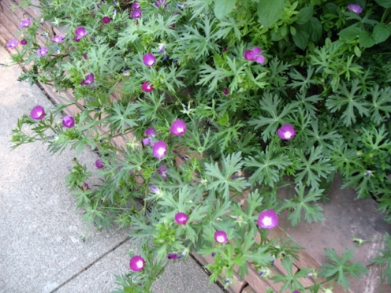  https://coloradoplants.jeffco.us/plant/details/205
Sulfur flower | Eriogonum unbellatum |  | 6-12” x 12-24” | Low | Full sun to light shade | 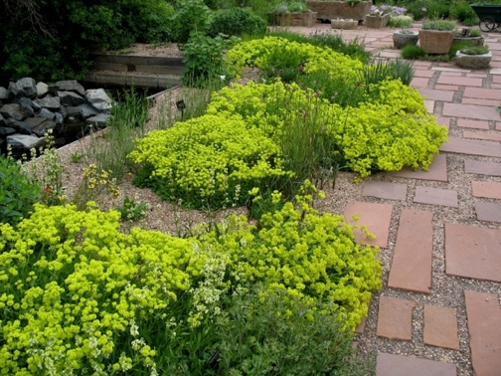  https://coloradoplants.jeffco.us/plant/details/432
Cowboy's delight or Scarlet Globemallow | Sphaeralcea coccinea |  | 10” x 10” | Low | Full sun | 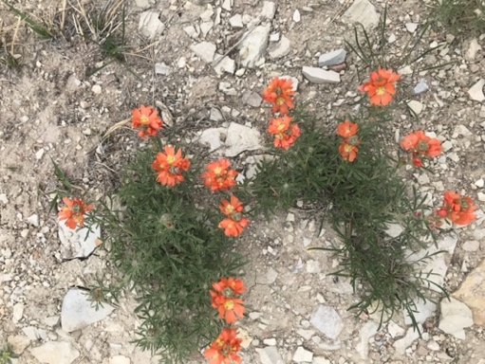  https://coloradoplants.jeffco.us/plant/details/932
Pussytoes | Antennaria spp. |  | 2-6” X 12” | Low to Medium | Full sun to part shade | https://coloradoplants.jeffco.us/plant/details/74  Photo by Master Gardener Jan B.
HERBACEOUS PERENNIALS
Fringed sage | Artemisia frigida |  | 4-18” x 24” | Low | Full sun | 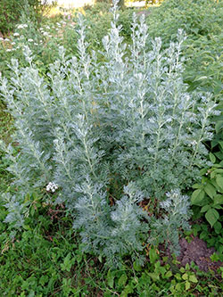  https://coloradoplants.jeffco.us/plant/details/129  Photo from CSU Extension Fact Sheet 7.230 Xeriscaping
Hyssops/Agastache (regional natives & hybrids) | Agastache rupestris and hybrids |  | 2-4’ x 1’ | Low | Full sun | 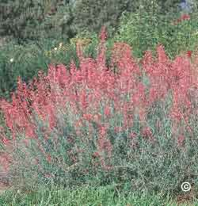  https://plants.usda.gov/le?symbol=AGRU  Photo from CSU Extension PlantTalk 1061 - Hyssop
Prickly poppy | Argemone polyanthemos |  | 2-4’ x 1-2’ | Low | Full sun | 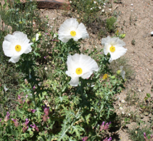  https://coloradoplants.jeffco.us/plant/details/118  Photo from:  https://extension.colostate.edu/docs/pubs/native/SE.pdf
Chocolate flower | Berlandiera lyrata |  | 18” x 18” | Low | Full sun | 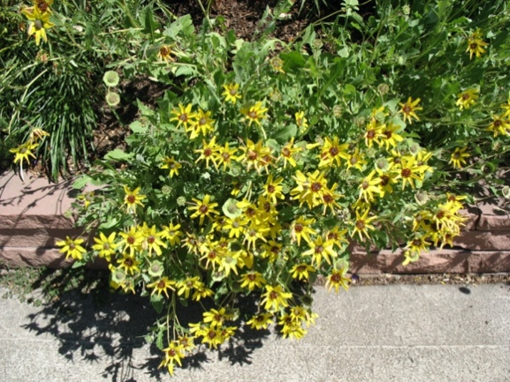  https://coloradoplants.jeffco.us/plant/details/1061
Blanketflower | Gaillardia aristata |  | 12” x 12” | Low | Full sun | 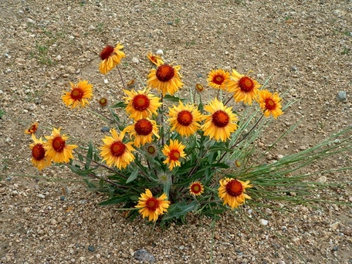  https://coloradoplants.jeffco.us/plant/details/453
Scarlet gilia/ Fairy Trumpet | Ipomopsis aggregata |  | 12-30" x 12" | Low | Full sun | 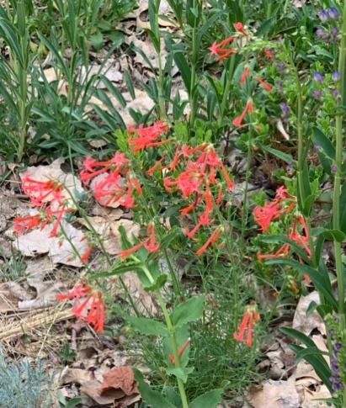  https://coloradoplants.jeffco.us/plant/details/519
Dotted blazing star | Liatris punctata |  | 24" x 12" | Low to Medium | Full sun to Part shade | 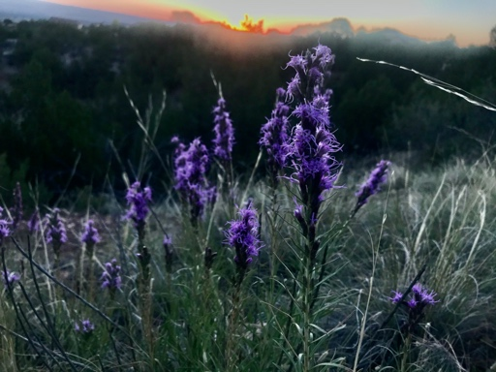  https://coloradoplants.jeffco.us/plant/details/543
White tufted evening primrose | Oenothera caespitosa |  | 6” x 12” | Low | Full sun | 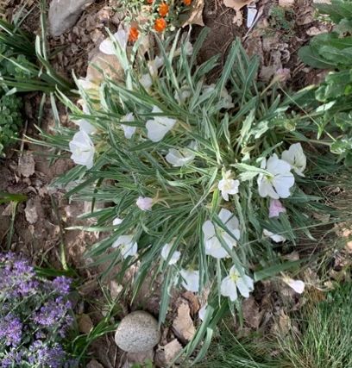  https://coloradoplants.jeffco.us/plant/details/634
Bluemist penstemon | Penstemon virens |  | 8” x 8-10” | Low | Full sun | 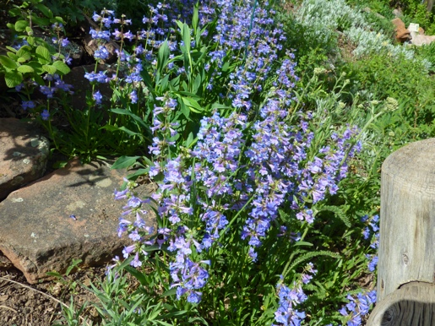  https://coloradoplants.jeffco.us/plant/details/722
One-sided penstemon | Penstemon secundiflorus |  | 20” x 12” | Low to Medium | Full sun to Part shade | 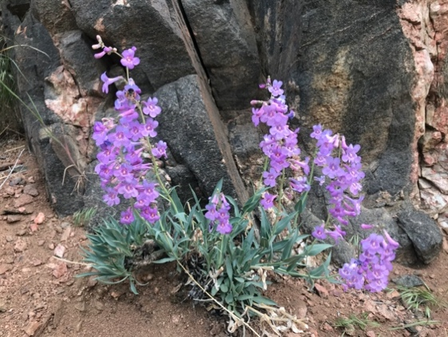  https://coloradoplants.jeffco.us/plant/details/720
Rocky Mountain penstemon | Penstemon strictus |  | 30” x 24” | Low | Full sun to Part shade | 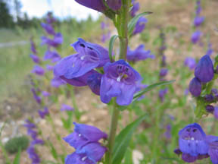  https://coloradoplants.jeffco.us/plant/details/721  Photo from https://extension.colostate.edu/docs/pubs/garden/07242.pdf
Prairie coneflower | Ratibida columnifera |  | 18” x 12” | Low | Full sun to Part shade | 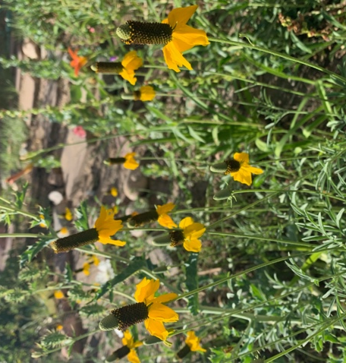  https://coloradoplants.jeffco.us/plant/details/827
Mojave sage (regional native) | Salvia pachyphylla |  | 18-24” x 24-30” | Low | Full sun | 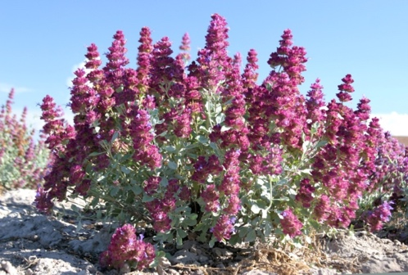  https://planttalk.colostate.edu/topics/annuals-perennials/1058-salvia/  Photo: Univ. of Wyoming Extension
Prince’s Plume | Stanleya pinnata |  | 24-48” x 12-18” | Low | Full sun | 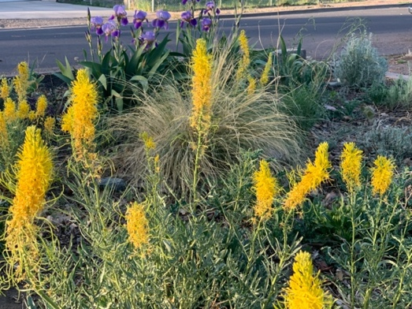  https://coloradoplants.jeffco.us/plant/details/937
LOW SHRUBS
Creeping Mahonia | Mahonia repens  (formerly Berberis repens) |  | 1’ X 4’ | Low | Full sun to shade | 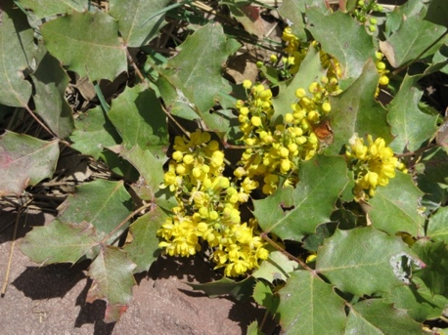  https://coloradoplants.jeffco.us/plant/details/584
Kinnikinnick | Arctostaphylos uva-ursi |  | 0.5-1' x  3-6' | Low to Medium | Full sun to Part shade | 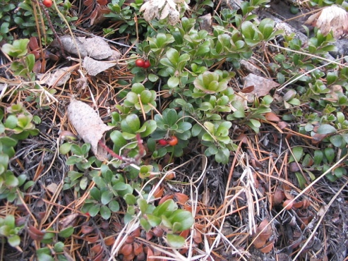  https://coloradoplants.jeffco.us/plant/details/116
SHRUBS & SMALL TREES
Manzanitas | Arctostaphylos x coloradensis |  | 1' x 2-3' | Low | Full sun to Part shade | 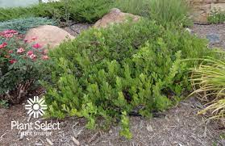  https://adams.extension.colostate.edu/horticulture/manzanita/  Photo from Plant Select
Western sage |  | Artemisia tridentata | 4-6' x 3-6' | Low | Full sun | 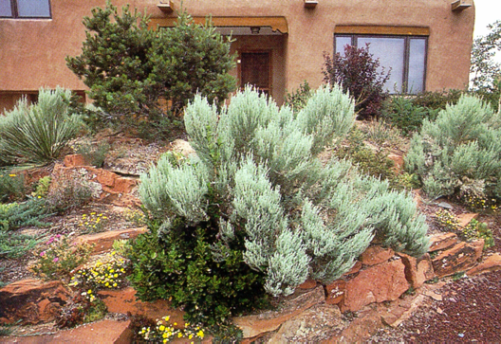  https://coloradoplants.jeffco.us/plant/details/899
Curl-leaf mountain mahogany |  | Cercocarpus ledifolius | 15’ x 15’ | Low | Full sun | 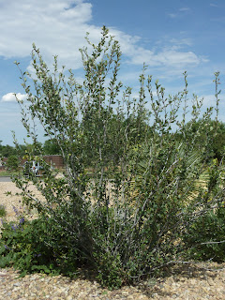  https://coloradoplants.jeffco.us/plant/details/1063
Fernbush |  | Chamaebatiaria millefolium | 6’ x 6’ | Low | Full sun | 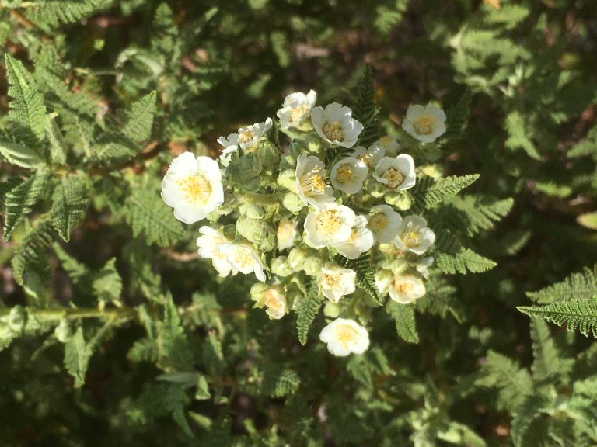  https://douglas.extension.colostate.edu/horticulture/educational-demonstration-gardens/csu-extension-in-douglas-county-gardens/
Rabbitbrush |  | Chrysothamnus nauseosus | 2-6' x 3-4' | Low | Full sun | 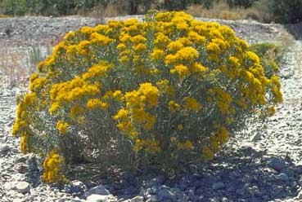  https://coloradoplants.jeffco.us/plant/details/104
Apache plume |  | Fallugia paradoxa | 6’ x 6’ | Low | Full sun | 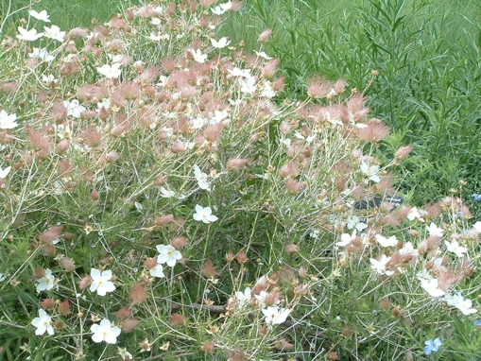  https://coloradoplants.jeffco.us/plant/details/444
Common juniper |  | Juniperus communis | 3’ x 8-10’ | Low | Full sun to part shade | 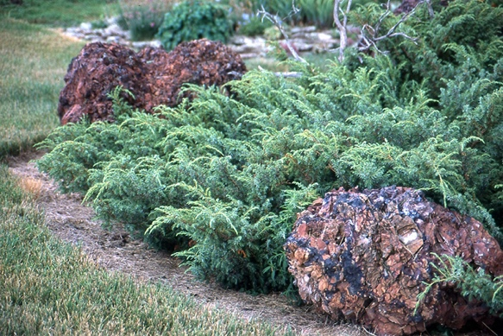  https://coloradoplants.jeffco.us/plant/details/356  Photo from Oregon State University: Landscape Plants
Winter fat |  | Krascheninnikovia lanata | 3’ x 2’ | Low | Full sun | 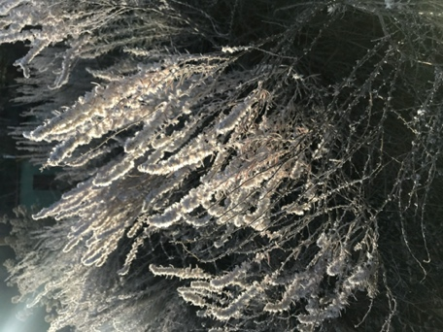  https://coloradoplants.jeffco.us/plant/details/358
Fremont mahonia |  | Mahonia fremontii | 6-10' x 6-10' | Low | Full sun | 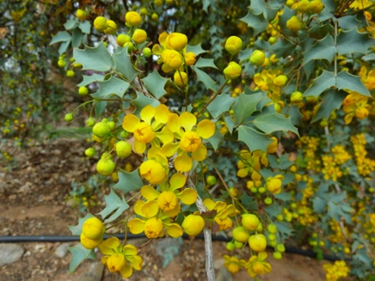  https://plants.usda.gov/home/plantProfile?symbol=MAFR3
Shrubby cinquefoil |  | Potentilla fruticosa | 4’ x 4’ | Low to medium | Full sun | 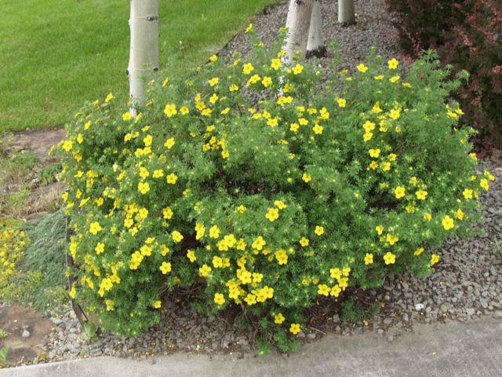  https://coloradoplants.jeffco.us/plant/details/725
Sandcherry |  | Prunus pumila var. besseyi | 6’ x 5’ | Low to medium | Full sun | 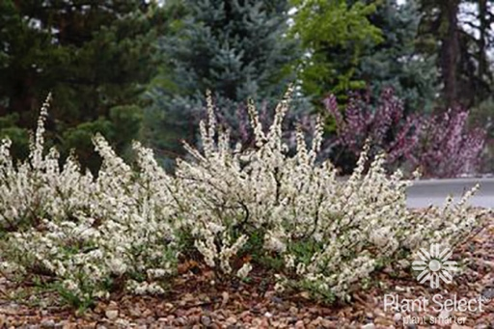  https://coloradoplants.jeffco.us/plant/details/249  Photo by D. Winger, Plant Select
Wafer-ash/Hop Tree |  | Ptelea trifoliata | 10-15’ x 5’ | Low to medium | Full sun to Part shade | 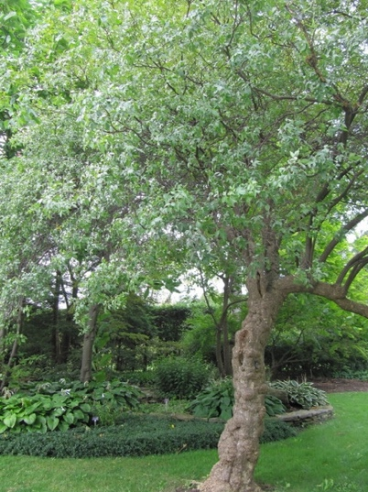  https://coloradoplants.jeffco.us/plant/details/1065  Photo by North Carolina State Extension
Boulder raspberry |  | Rubus/Oreobatus deliciosus | 8’ x 6’ | Low to medium | Full sun to Part shade | 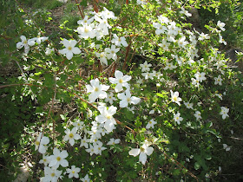  https://coloradoplants.jeffco.us/plant/details/653
ORNAMENTAL GRASSES
Blue grama |  | Bouteloua gracilis | 12-14" x  12-18" | Low to medium | Full sun to Part shade | 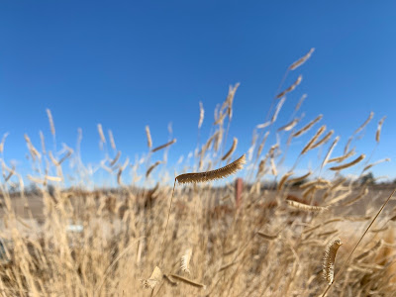  https://coloradoplants.jeffco.us/plant/details/99  Photo by Amy Lentz, Weld County Extension
Little bluestem |  | Schizachyrium scoparium | 24-48" x  18-24" | Low | Full sun | 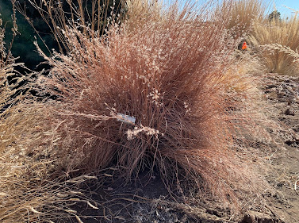  https://coloradoplants.jeffco.us/plant/details/880  Photo by Amy Lentz, Weld County Extension
Indian rice grass |  | Oryzopsis hymenoides  (Achnatherum hmenoides?) | 12-24" x  8-12" | Low | Full sun | 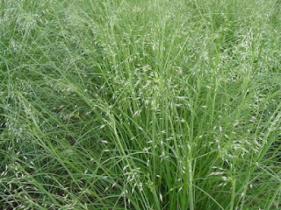  https://coloradoplants.jeffco.us/plant/details/9  Photo credit: L&H Seeds, Indian Rice Grass in CSUHort blog
CACTI
Prickly Pear |  | Opuntia phaeacantha | 1.5-2' x 3-6' | Low | Full sun | 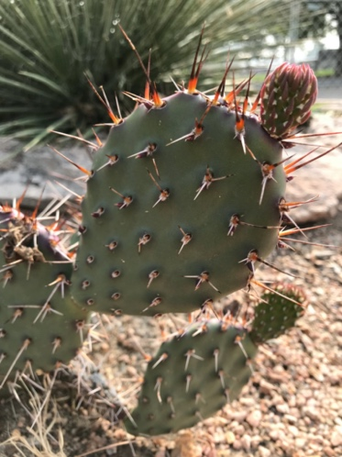  https://coloradoplants.jeffco.us/plant/details/651
Agaves  (details and picture for Parry’s Agave – regional native) |  | Agave parryi | 12-36” x 12-36”  (flower stalk 10-20’) | Low | Full sun to Part shade | 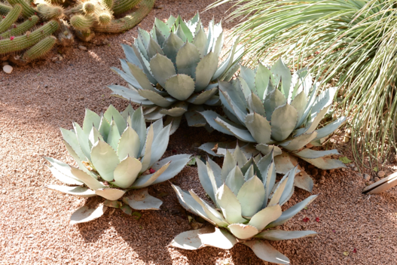  https://plants.ces.ncsu.edu/plants/agave-parryi/  Photo from NC State Extension
Claret cup cactus |  | Echinocereus triglochidiatus | 15-24" x  15-24" | Low | Full sun | 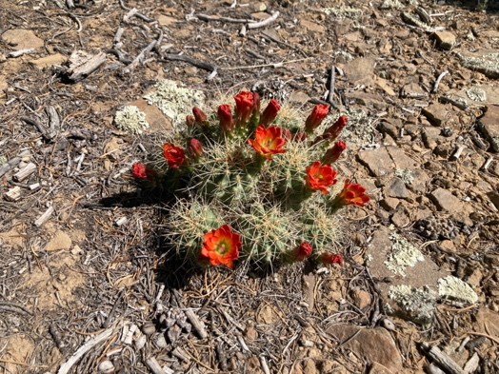  https://coloradoplants.jeffco.us/plant/details/383
Yuccas (not really a cactus)  Banana Yucca |  | Yucca baccata | 1-2' x 4-6' | Low | Full sun | 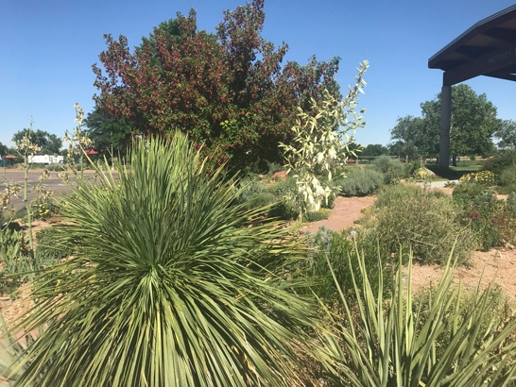  https://coloradoplants.jeffco.us/plant/details/1039
Soapweed |  | Yucca glauca | 16-20" x  24-36" | Low | Full sun | 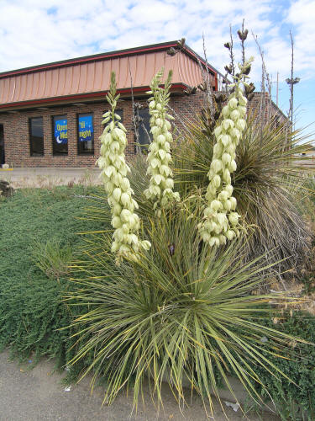  https://coloradoplants.jeffco.us/plant/details/1040  Photo from Missouri State University

Native & Xeric Gardening Resources
- Native Grasses: ​​https://cmg.extension.colostate.edu/Gardennotes/581.pdf
- Native Herbaceous Perennials: https://extension.colostate.edu/docs/pubs/garden/07242.pdf
- Native Trees: https://extension.colostate.edu/docs/pubs/garden/07421.pdf
- Native Shrubs: https://extension.colostate.edu/docs/pubs/garden/07422.pdf
- Low Water Native Plants for Colorado Gardens:
  - Prairie and Plains: https://extension.colostate.edu/docs/pubs/native/Prairie.pdf
  - Front Range and Foothills: https://extension.colostate.edu/docs/pubs/native/FrontRange.pdf
  - Prairie: https://extension.colostate.edu/docs/pubs/native/PrairieSm.pdf

Demonstration Gardens that have Native Plants:
- CS Utilities Demonstration Gardens:
2855 Mesa Road, Colorado Springs or 3920 Dublin Blvd., Colorado Springs
- Horticultural Arts Society Gardens: 222 Mesa Rd and Glen Ave, Colorado Springs, CO
- Wild Ones: Front Range - listing of native gardens in Denver and surrounding areas: https://frontrange.wildones.org/resources/demonstration-gardens-with-native-plants/
- Nix Native Plant Garden: 1745 Homan Mill Road, Fort Collins, CO
- High Plains Environmental Center Native Plant Demonstration Garden: 2698 Bluestem Willow Dr, Loveland

