El Paso County 4-H Annual Project Plan

Instruction for 4-H Project Leaders:
- Annually, complete one plan per project
- Submit to 4-H Extension Office
- Distribute to parent/guardian annually
- Add rows as necessary to sections below.

Name & Date:
Project Name:
County
Program Year:

Contact Information:

Project Leader Names (there must be at least two) | Email | Phone | Registered 4-H Volunteer?

List Goals for Project Completion for the Youth:
(What would you like to youth to learn, exhibit, and see growth in?)

List Project Leader expectations of Parent/Guardian: (e.g., parent/guardian needs to walk their child in and sign them out, do parent/guardians need to stay, provide supplies, provide completed forms, drop off and pick up times, extra fees, etc.)

Belonging:
What strategies will you use to ensure that members and families feel welcome and that they belong?

Outline of Project Meetings
(Fill out for the upcoming 4-H year)

Date & Time | Location | Topic | Learning Activity  (Please list if guest or clinician will be teaching) | Event Plan Submitted?  (Yes or No) | Home Assignment or Deadline Reminders

(add lines as needed)

Reflection Log of 4-H Annual Project Meetings

Outline of Project Meetings for:
______________________________________________________
(Fill out after the event to signify any adaptations or changes to original outline)

Were there adaptations to the meetings? Please list changes below | Date & Time | Location | Topic | Learning Activity  (Please list if guest or clinician will be teaching) | Event Plan Submitted?  For extension agents | Home Assignment or Deadline Reminders

(add lines as needed)

Experiential Learning Model
It is vital as we support positive development in youth that we help participants learn life skills, growing in each of the four parts of the Clover: Head, Heart, Hands, and Health. How do we teach these skills using research supported, youth-centered, active learning? We use the Experiential Learning Model!
Most educators and experienced 4-H volunteers will tell you that the best way to engage youth in learning is to create experiential learning opportunities, allowing youth to explore and discover rather than listen to lectures or read information. In fact, the science behind how we learn supports this theory. We are more likely to remember things that we do or teach other people rather than information that we read or hear.
The Experiential Learning Model is a teaching method that focuses on creating experiences for youth and taking time to process those experiences as a group. The reflection portion of learning encourages young people to apply new life skills in different situations. It shifts the experience from a fun activity to long-term learning and application.
How did the project meetings implement the experiential learning model?
- Youth do and share what they did during an activity
- Youth reflect what they did (including what they learned)
- Youth think about how to use what they did and learned, and how they can apply that

Experiential Learning Model Questions to ask the Youth
- Experience (Do the Activity)
  - What are you planning to do? What did you expect to happen? How is it working?
- Reflect (Share about the Activity)
  - Describe what you did
  - What was difficult? Easy?
  - What challenges did you have? What might make it better?
- Apply (Generaize, Learn, and Connect)
  - How does this skill relate to… home/school/work/etc?
  - How can this skill benefit you now or in the future?

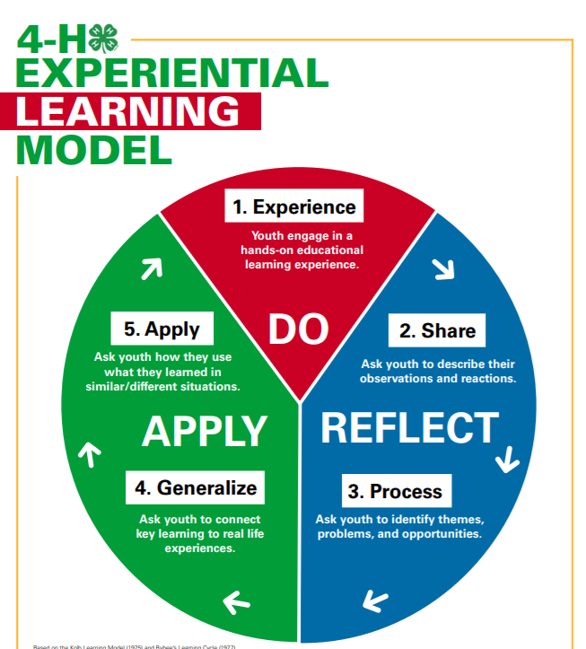

Colorado University Extension is an equal opportunity provider.
Colorado State University does not discriminate on the basis of disability and is committed to providing reasonable accommodations.
CSU's Office of Engagement and Extension ensures meaningful access and equal opportunities to participate to individuals whose first language is not English.
https://col.st/0WMJA

Colorado State University Extension es un proveedor que ofrece ingualdad de oportunidades.
Colorado State University no discrimina por motivos de discapacidad y se compromete a proporcionar adaptaciones razonables.
Office of Engagement and Extension de CSU garantiza acceso significativo e ingualdad de oportunidades para participar a las personas quines su primer idioma no es el ingles.
https://col.st/0WMJA

*Referenced and adapted by Wisconsin 4-H

