2024 El Paso County Fair

Fair Entry Registration
Instructions

Table of Contents

- Signing in……………………………………………………………………………….… 3

- Additional Question Section………………………………………….…………………. 5
  - What if I need to change my answers to these questions later during the registration process?.................................................................................... 6

- Registering for non-animal fair classes………………………………………………... 7
  - Helpful information before you begin………………………………………….. 7
  - Adding entries……………………………………………………………………. 7
General Consumer Science, 4-H Shooting Sports,
    - Tabletop, & other Non-Living Animal Exhibits entries will prompt you to answer two additional questions………………………………………………………………… 9

- Registering for Animal Shows at fair……………………………………………………12
  - Helpful information before you begin…………………………………………..
  - Adding Animals…………………………………………………………………..13
    - Animal shows where 4HOnline Animal ID was required …………...13
      - Horse, Dog, Cat, Llama/Alpaca, Breeding Beef; Breeding Swine; Breeding Sheep; Breeding Boer Goat; Dairy Goat; Pygmy Goat, Market Swine
    - Animal Shows where 4HOnline Animal ID was NOT required…….14
      - Market Beef; Market Sheep; Market Goat, Cavies, Pocket Pets, Poultry, Rabbits
  - Registering animals for fair classes……………………………………………15
  - Animal Show divisions that don’t require adding animals…………………...17

- Submitting Registration……………………..……………………………………………18

Signing In

You can find the 2024 El Paso County Fair by following this link: https://fairentry.com/Fair/SignIn/19827
OR
Go to http://www.FairEntry.com, select ‘Find Your Fair’ across the top and search by keyword: El Paso. You should then see the 2024 El Paso County Fair populate on the right side of your screen (if on a computer).
When you click on the fair link you should then be taken to a log in page with the following options:
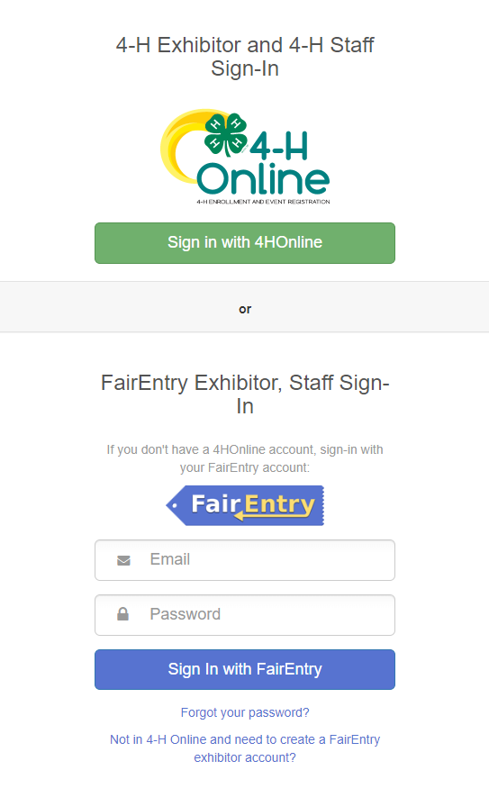
4-H Families: MUST log in through 4HOnline, please contact the Extension Office if you have any difficulties logging in.

FFA Families: please create an account using the bottom option. If you have logged in to Fair Entry before, please use the same email and password. Click on the forgot password link to reset your password. Contact 719-520-7698 with any issues logging in.
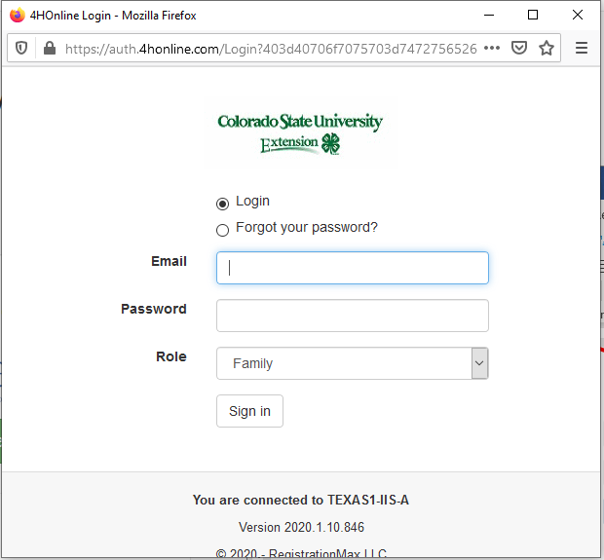
When you select ‘Sign in with 4HOnline’, the following window will pop up:

If you do not get the pop-up login window, please disable your pop-up blocker or consider using the following browsers:
- Mozilla Firefox
- Google Chrome

Your fair entry home screen will appear as in the image below, click on Begin Registration and then click Individual.
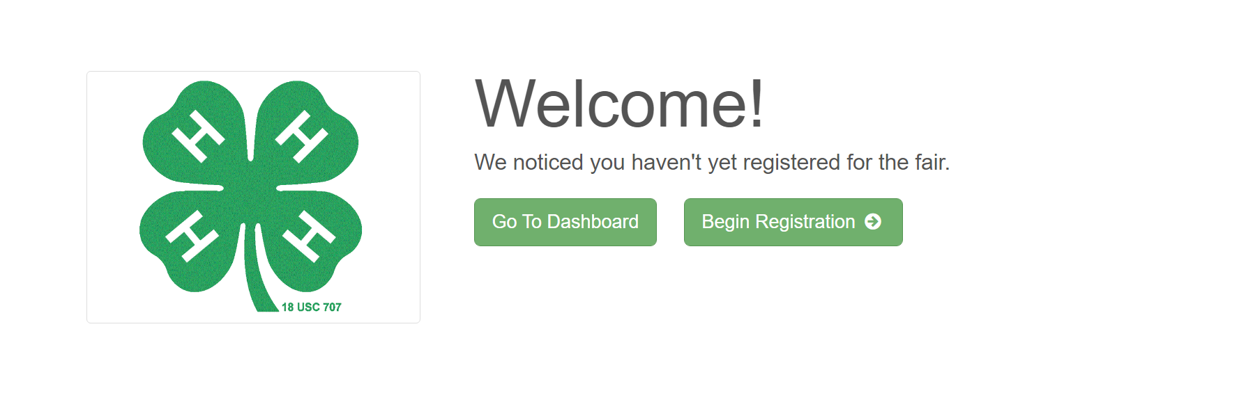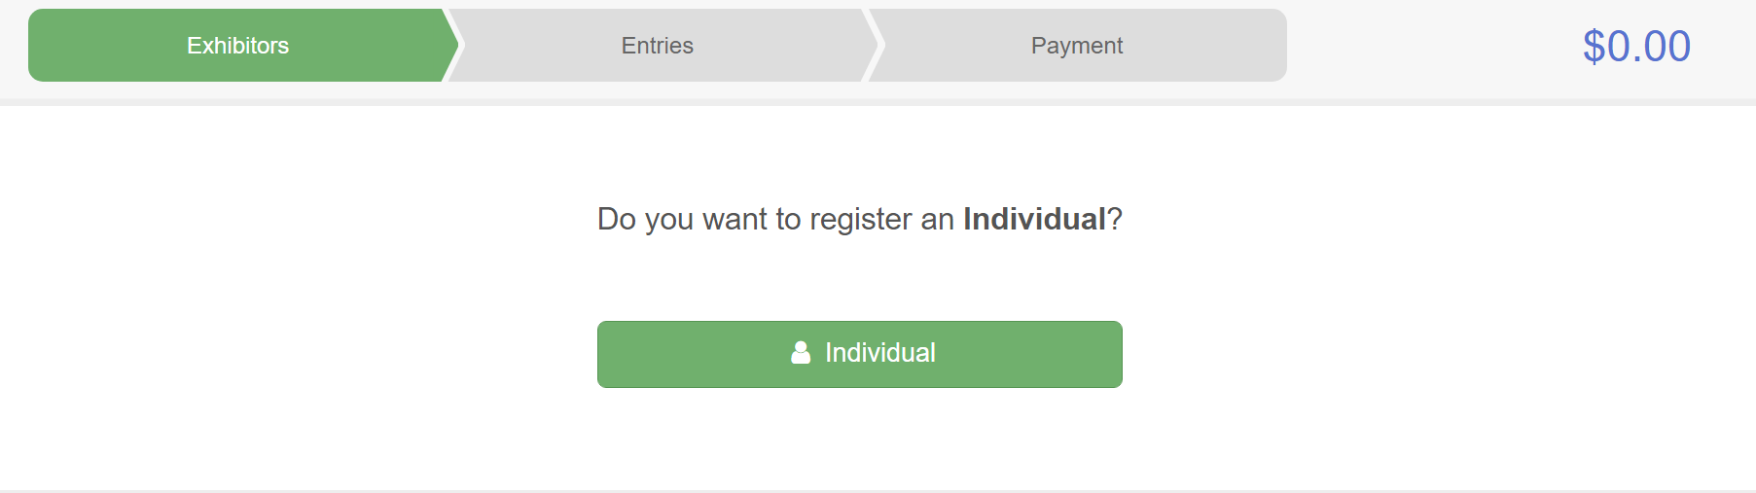
A page should then pop up with a list of all your active 4-Hers, select one and click Continue to begin registering them for fair.

Additional Question Section

Once you select a 4-Her and click continue, you will arrive at a Questions section,
- An answer to every question is required
- You will need to answer these questions for EACH 4-Her registering for fair
- All questions should have a ‘0; or ‘None’ option if they are not applicable
Please answer all questions and click Continue at the bottom right corner of the page.
This will take you to a Review Section (pictured below) where you can see your answers to each question and make changes, if needed, by selecting Edit at the top right corner of the Additional Questions box.
To begin registering your 4-Her for fair classes select Continue to Entries.
*You will have to know your member’s 4-H Age to enter classes (5-7-Cloverbud; 8-10 Junior; 11-13 Intermediate; 14+ Senior) You can confirm 4-H age on this screen (top left corner under your 4-Hers name)

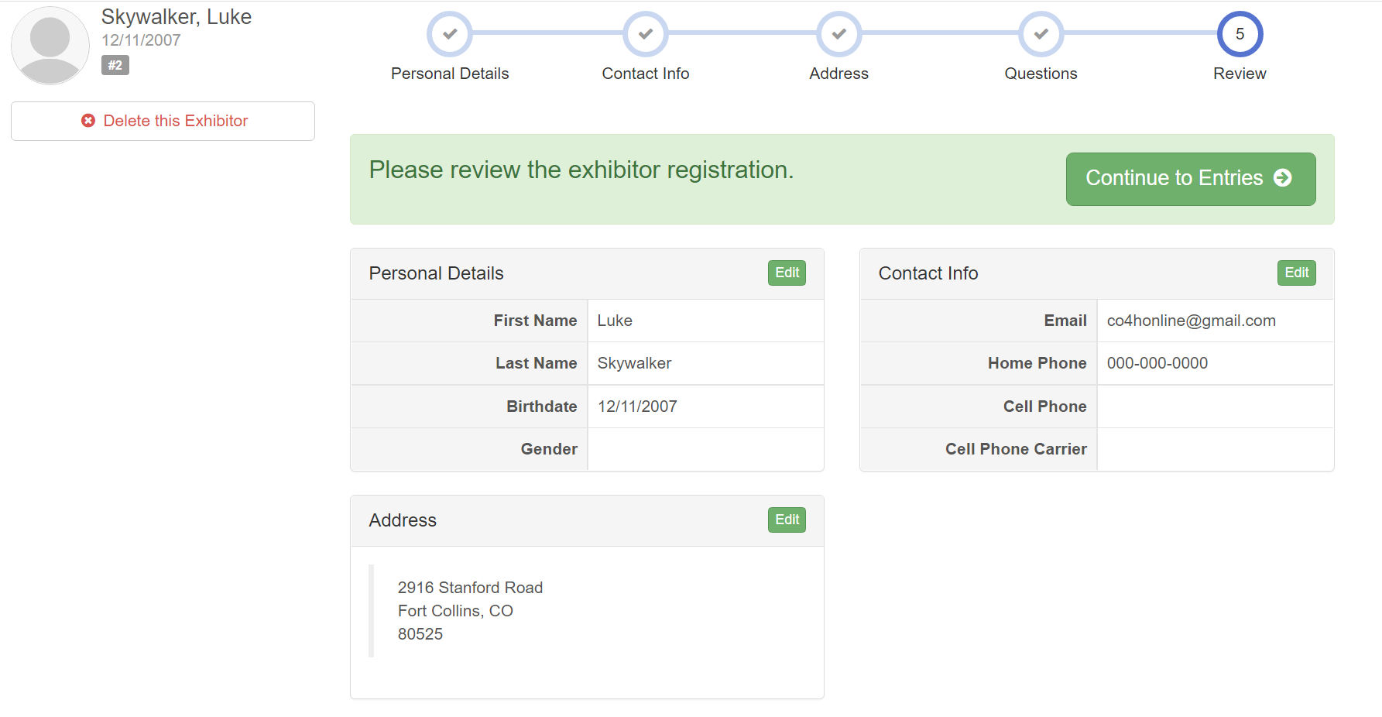

a: What if I need to change my answers to these questions later during the registration process?

Edit these questions any time by selecting Exhibitors on the menu bar across the top of your screen.
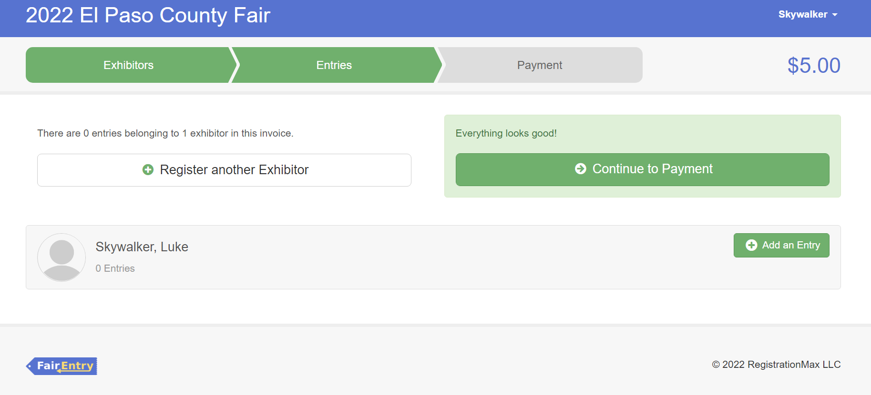

This should take you to the screen to the right which lists all exhibitors you have begun registering so far.
Select Edit to the right of the 4-Her’s name.
This will take you to the Review Page (pictured on page 5), where you can edit the Questions section on the bottom right.
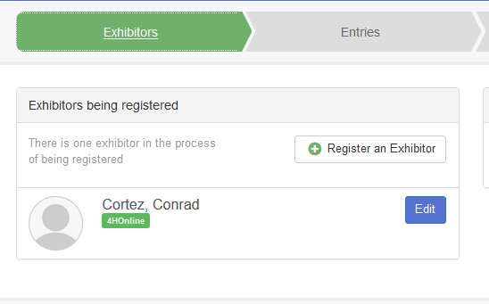

Registering for Non-Animal classes (including ALL Cloverbud fair participation options)

Some helpful information before you begin:

    - Divisions are listed in the same order as the 2024 Colorado State Fair 4-H Exhibit Requirements: this document also:

    - Provides Display Board Guidelines on page 6
    - Provides expectations and guidelines for fair submission for each project/class
    - Find it on our EPC Extension website on the Fair Resources page

  - All Tabletop/General: General Consumer Science, 4-H Shooting Sports exhibits, & other Non-Living Animal Exhibits entries will prompt you to answer two additional questions and take you to an ‘Entry Files’ section:

    - Provide a detailed description of your entry: please provide relevant details to help Fair Staff identify your project, and please be very specific
      - Example 1: Unit 1 cake, white frosting & M&Ms decorations arranged in a heart.
      - Example 2: Tri-fold display board entitled “History of the Compound Bow”
      - Example 3: STEAM Clothing 1, purple dress with running horses pattern.
    - Do you want to interview for this class?
    - ‘Entry Files’: This section allows photo uploads- PLEASE SKIP THIS SECTION

Adding entries:
Once you reach the Entries section, you should see the screen below:
Click Add an Entry to the right of your exhibitor’s name.
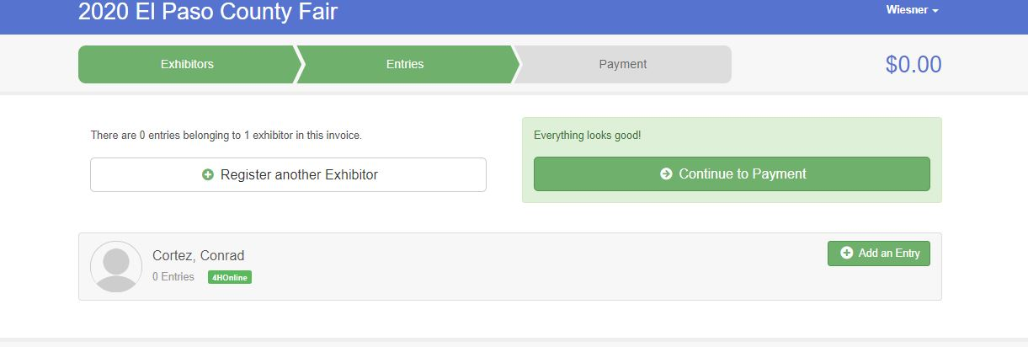
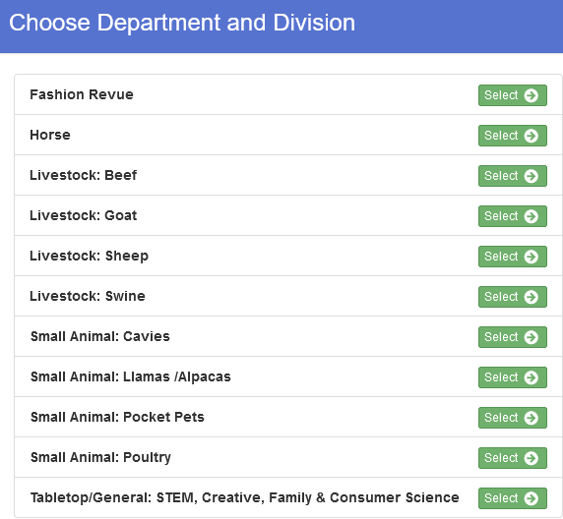
A screen should pop up showing the menu to the right.
This list includes all departments in the 2024 El Paso County Fair.
Tabletop/General: STEM, Creative, Family & Consumer Science include all non-animal project fair classes, click Select to the right.
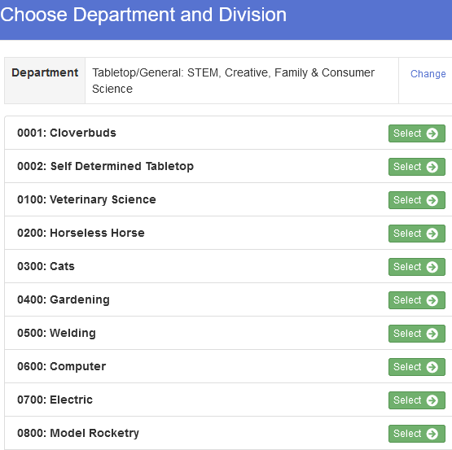
The menu to the right should then populate.
Each project is a division including Cloverbud, Pocket Pets Stand-Alone and Self-Determined, listed at the top.
Your 4-Her will need to be enrolled in that project in 4HOnline to enter a class within it.
Click Select next to the appropriate division/project.
Click Choose on the next screen to confirm.

You will then see a screen like the one pictured below listing all the classes within that project/division.
- You can register for more than one class at a time for example if your 4-Her enrolled in Horseless Horse Unit 1 and Unit 2.
- Please be sure to select the appropriate Age Division (Junior, Intermediate, Senior) and Unit #, if applicable.
- You can check the projects that your 4-Hers are enrolled in by logging in to co.4HOnline.com.

Check the appropriate boxes and the click Continue on the top right corner.
Click Create Entries on the bottom right corner of the next screen that pops up to confirm your selection.
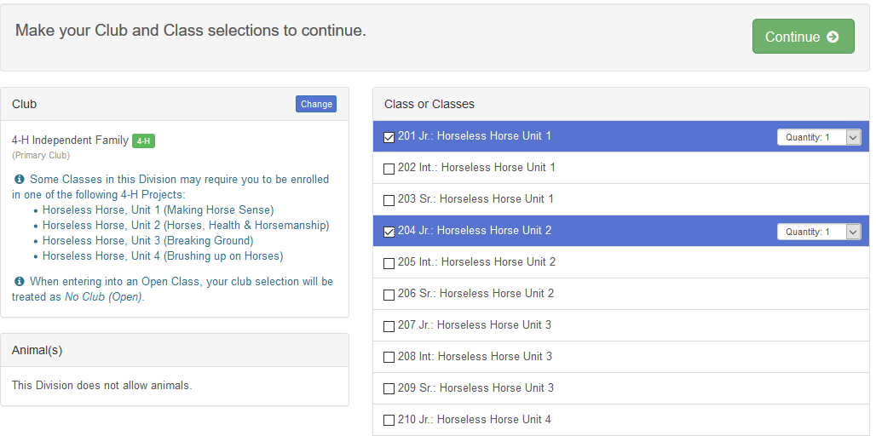
Once you confirm your class entries, you will go back to the Entries screen pictured below:
At the top right you should see a button labeled Review/Complete Outstanding Records.
Clicking this button will lead you to submit answers to the two required questions for each Tabletop/General: STEM, Creative, Family & Consumer Science entry.

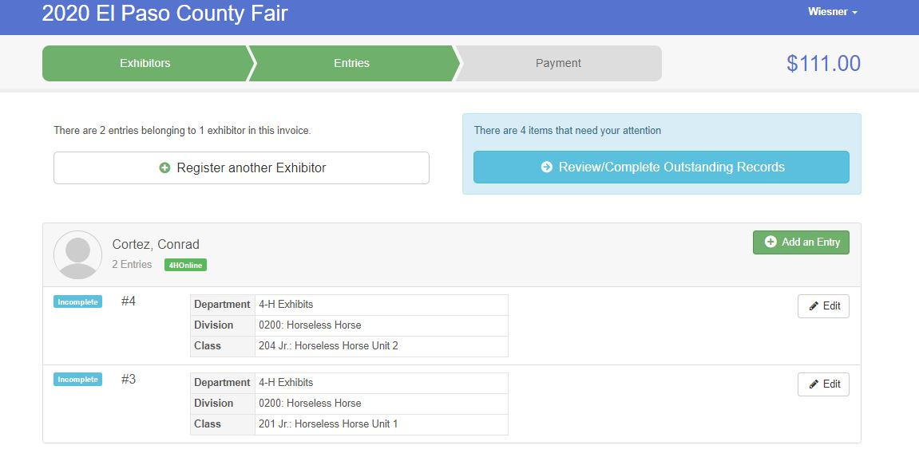
Question 1: Entry Description: Provide a detailed description of your entry: please provide relevant details to help Fair Staff identify your project, and please be very specific
Example 1: Unit 1 cake, white frosting & M&Ms decorations arranged in a heart.
Example 2: Tri-fold display board entitled “History of the Compound Bow”
Example 3: STEAM Clothing 1, purple dress with running horses pattern.
Click Continue when you are done.
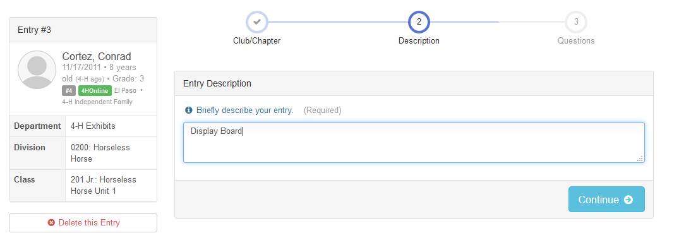
: 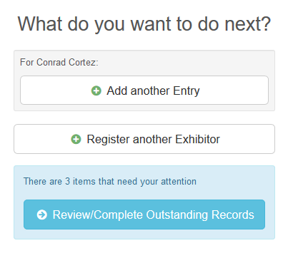
You will then see the What to do Next? options pictured to the right.
Click Review/Complete Outstanding Records to answer all remaining questions for your Tabletop/General: STEM, Creative, Family & Consumer Science entries.
Question 2: Do you want to Interview for this project?
If you are unsure which entry a question is referring to, confirm by reviewing the Class Name, highlighted on the left side of the screen below.
Answer this question and click Continue to the What to do next? screen pictured above. Select Review/Complete Outstanding Records until all required questions have been answered.
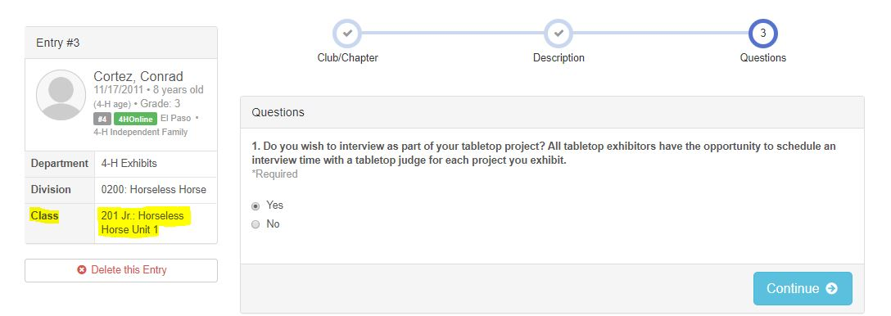

Entry Files Section: This section is not required and can be skipped. Please select Continue at the bottom of the page.
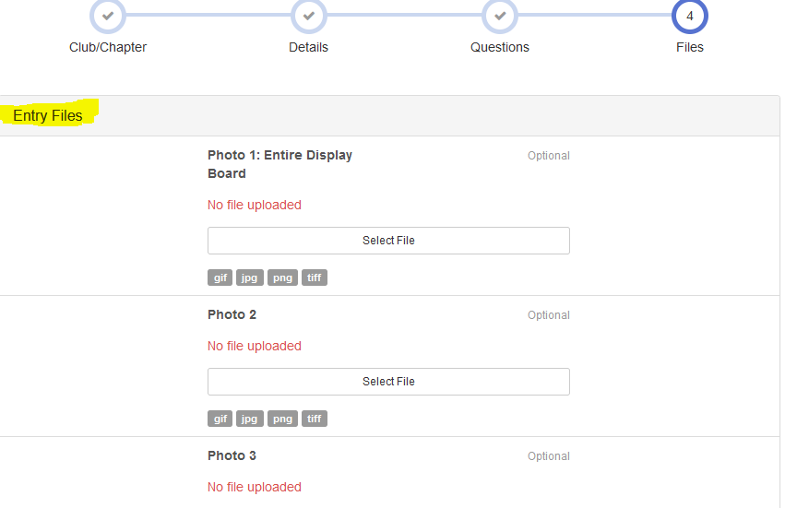
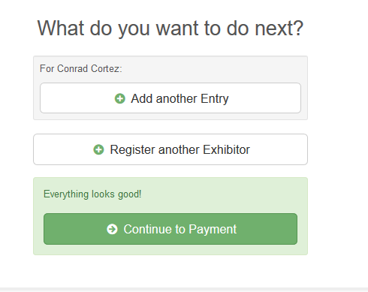
Once all questions are answered for all selected entries, the options to the right should populate.

Click Add another Entry if you would like to register for more fair classes.
Click Register another Exhibitor to begin the registration for another member.
Click Continue to Payment if you are done registering all your 4-Hers for Fair.
If you select Add Another Entry, the screen to the right will pop up.
Click Change to the right of the department to enter the Fashion Revue, Creative Cooks Contest or an animal show.
Click Change to the right of the division to enter other non-animal project/division such as leadership or etymology.
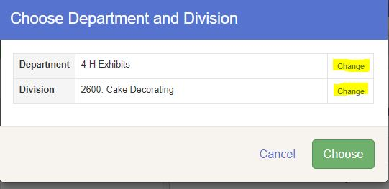

Registering for Animal Shows

Some helpful information before you begin:
    - For a complete list of classes within any animal show please refer to the Animal Premium Books on the CSU Extension, El Paso County website https://elpaso.extension.colostate.edu/county-fair/

    - If you are ever unsure which class, detailed class descriptions and competition rules can be found in the appropriate show premium.

From the Entries screen shown below select Add an Entry.
If you are not currently on that screen you can navigate there by selecting Entries on the menu bar across the top of your screen.
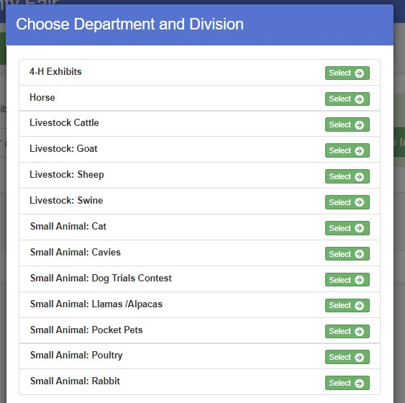
A screen should pop up showing the menu to the right.
This list includes all departments in the 2024 El Paso County Fair.
Click Select next to the show that you would like to register for.
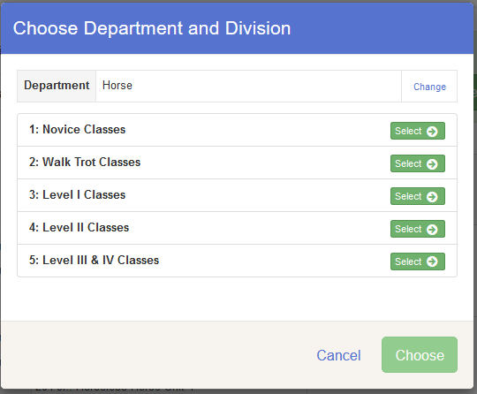
The next menu lists all Divisions within that department.
Horse, for example lists all divisions by levels.
Click Select to the right of the division you wish to enter.
Click Choose on the next screen to confirm your selection.

Adding Animals: Some Divisions will require you to add animals, divisions that require animal entry will have a box like the one highlighted in the screen below which prompt you to Add Animal. There are two ways to add animals:
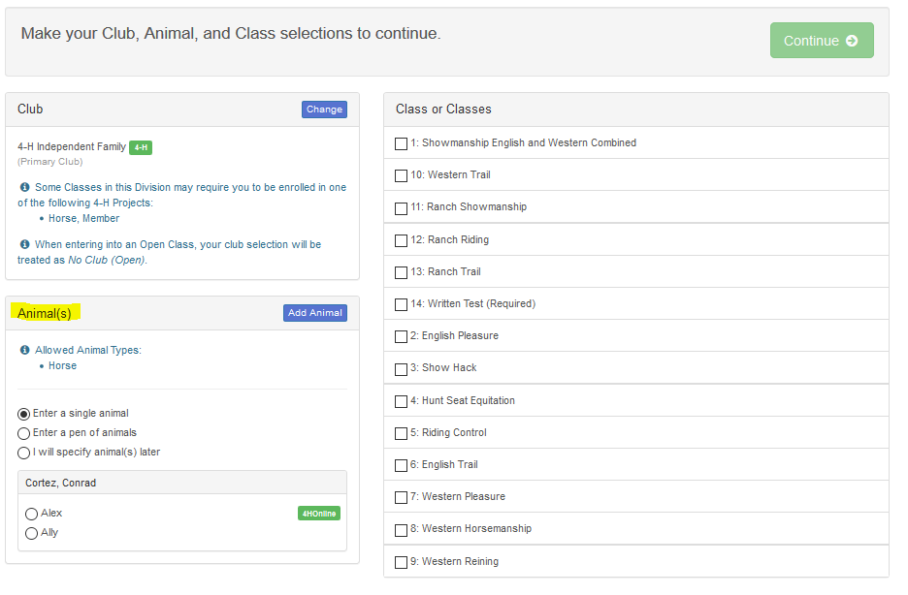

- Importing Animals from 4-HOnline: for all animals that required 4HOnline IDs before May 1, you will not be able to enter these classes with animals entered from scratch.

- Required for: Breeding Beef, Breeding Sheep, Breeding Swine, Breeding Boer Goat, Pygmy Goat, Dairy Goat, Horse, Miniature Horse, Dog, Cat, and Camelid

For these projects all completed IDs should populate for the animal type allowed in the division, Camelid, in the example shown below.
Each Animal ID should have a check box to the left of it, select one or all and click Import Selected.
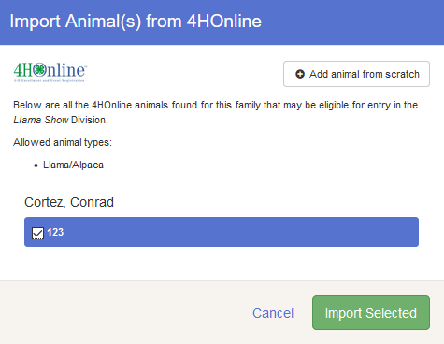

- Add animals from scratch: Select this for all divisions in which an Animal ID in 4HOnline was not due by May 1.

- Required for: Market Beef, Market Sheep, Market Goat, Market Swine, Pocket Pets, Cavy, Rabbit, and Poultry
For these projects, select Add animal from scratch.
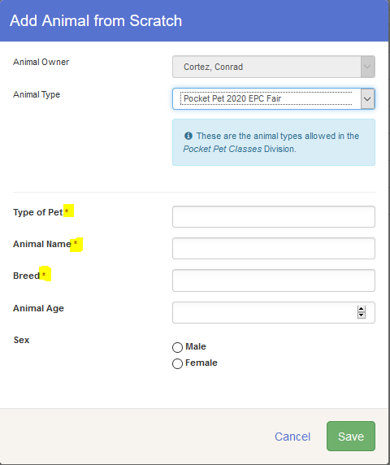
Select the Animal type from the drop-down menu and then complete the fields that populate below it.
Some Animal Types require more information than others such as the example to the right: Pocket Pets
Fields with a ( *) are required, other fields have been listed but are not required.
Complete all fields and then select Save on the bottom right of the pop-up window.

Registering animals for fair classes

Once you have added your animal(s) you can register for classes.
Only one animal can be registered at a time. In the example below, this member has added three market goats but only the goat tagged XYZ is being added to the Market Goat Class.
This member will click Continue and then click Confirm on the next screen to submit their entry.
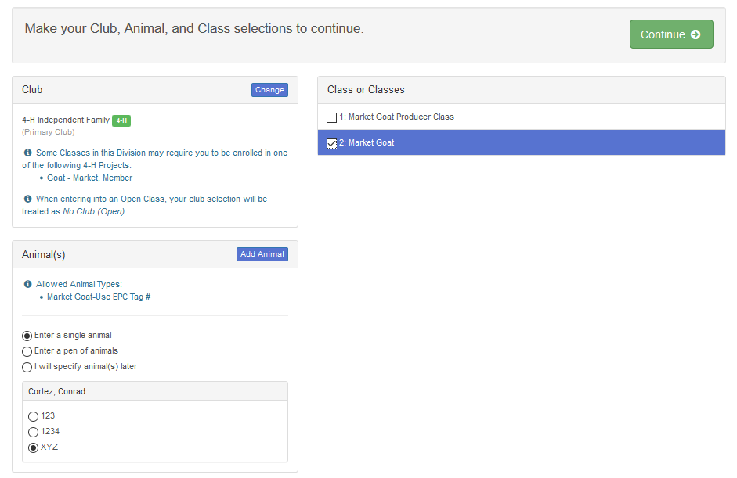

Once the entries are confirmed, this member will be taken back to the Entries screen, where they will need to select Add an Entry to enter their other goats into the market goat show.

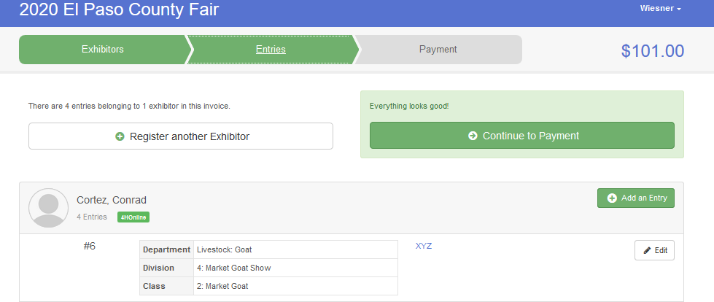
Select the Livestock Goat department.

Select the Market Goat division and then select Choose on the screen that pops up to confirm the selection.

When they return to the Market Goat classes, they will be able to select a different goat to register, check the appropriate class and click Continue.
All animals previously added are still there to choose from.
This process will need to be repeated for the third goat.
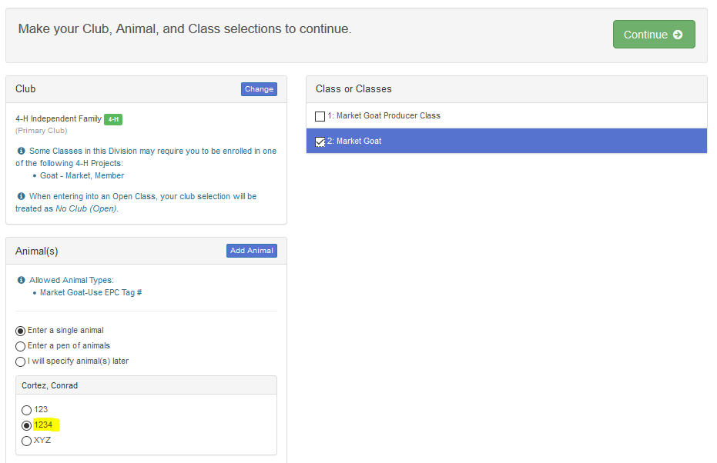

Registering for animal shows where adding animals are not required (Showmanship, Premier Exhibitor, etc.

Some animal show divisions such as Showmanship or Premier Exhibitor do not require any animals to be added, when you enter theses division you will see a screen like the example below.
On the bottom left you will see the message ‘This Division does not allow animals’ highlighted below.
This 4-Her is entering hogs in both the Market and Breeding Swine division and must register for both Breeding and Market Showmanship, they can simply check the appropriate boxes for their age division, click Continue and then click Create Entries on the next screen to confirm.
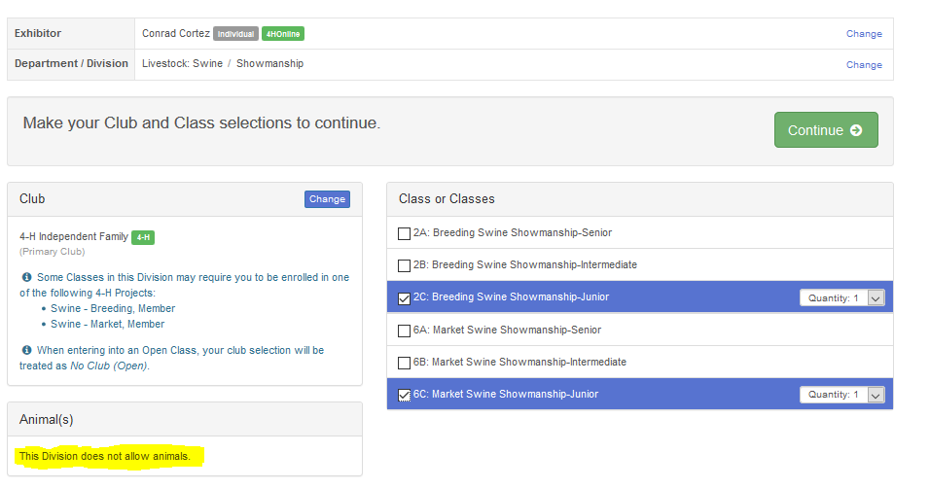

Submitting your registration

Once ALL 4-Hers in your family have been registered for classes, submit your entries by selecting Continue to Payment as shown on the screen below.
If you have not yet registered all your 4-Hers, select Register another Exhibitor.

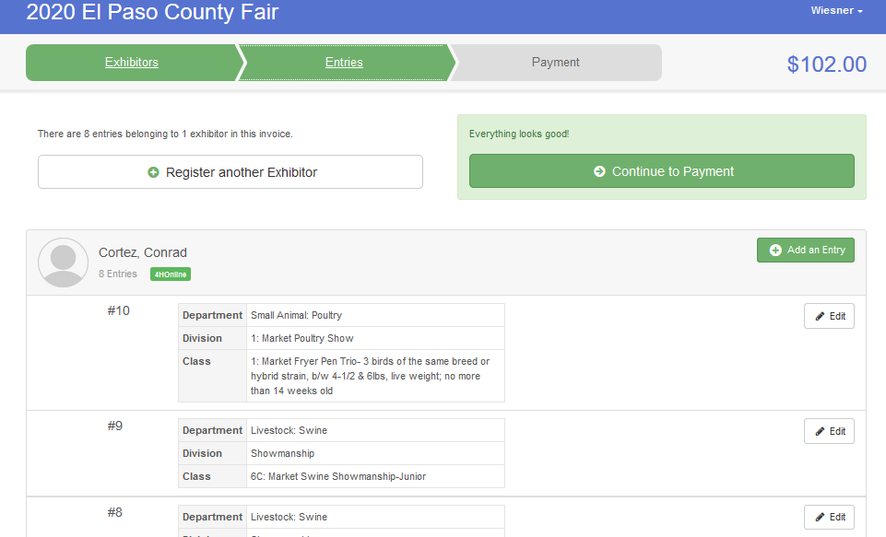

You will be able to review you invoice on the next screen, click Detail as pictured below to see each individual fee incurred, when you are done reviewing, click Continue at the bottom left.
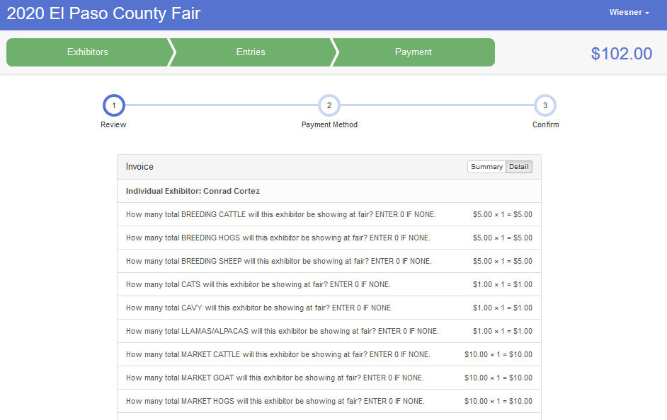
You should see the message below on the following screen, click Continue.

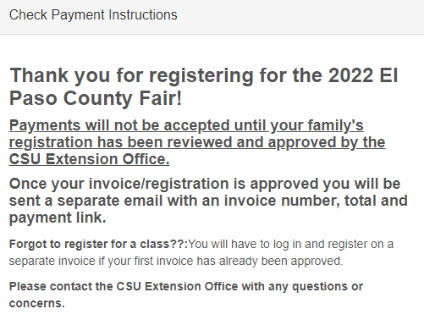
You will then reach the final screen shown below, click the box next to I agree to the above statement and click Submit to finish your registration! An email will be sent from the extension office with payment information once your submission has been reviewed in FairEntry.

