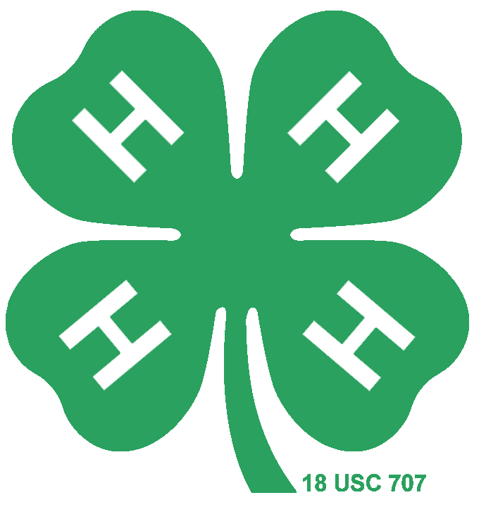
Premier Exhibitor
Horse Study Guide

4-H Horse Project- Colorado State University Extension
Colorado 4-H Horse Show Rulebook
- Breeds (Page 4)
- Color & Markings- Body Colors (Page 9)
- Teeth & Determining a Horse’s Age (Page 13)
- Pre-Purchase Exam (Page 16)
- Grooming-Hoof Care (Page 31)
- Feeding & Nutrition- Anatomy and Physiology of the Digestive Tract (Page 38)
- Pasture Management (Page 55)
- Riding Aids, Gaits, and Lateral Work- Body Position and Aids in Motion (Page 121)
- Western Tack and Equipment- Bridle (Page 104)
- Health Problems & Diseases-Colic (Page 77)
- Horse Judging (Page 140)
- Riding Aids, Gaits, and Lateral Work-Lateral Movements (Page 126)
- Feeding & Nutrition- Types of Feed (Page 44)
- General Health- (Page 75)
- Feeding & Nutrition- Hay (Page 42)
- Common Poisonous Plants in Colorado (Page 50)
- Health Problems and Diseases- West Nile (Page 83)
- Body Positions and Aids In Motion- Posting or Rising Trot (Page 121)
- Body Position and Aids In Motion- The Correct Lead (Page 122)
- English Classes (Colorado 4-H Horse Show Rulebook 2024)
- Description of Body Condition Score System (Page 47)
- Reproduction- Breeding (Page 59)
- Reproduction-New Foal Care (Page 61)
- English Tack & Equipment (Page 107)
- Health Problems and Diseases (Page 86)
- Parasites (Page 91)
- Ranch Horse Discipline- Cow Work (Page 137)
- Individual Events- Barrel Race (Colorado 4-H Horse Show Rulebook 2018)
- Western Riding (Colorado 4-H Horse Show Rulebook 2018)
- Health Problems & Diseases (Page 83)

