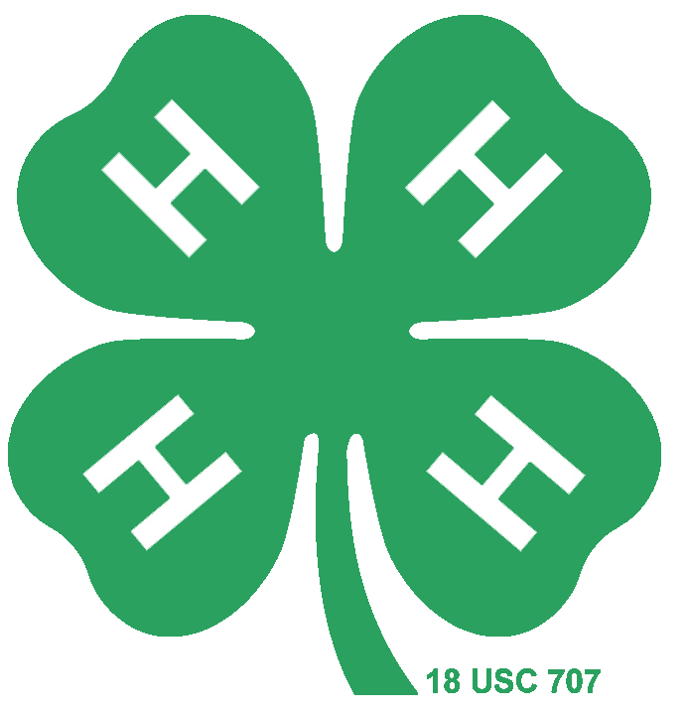
Premier Exhibitor
Miniature Horse Study Guide

4-H Small Equine Ohio State University

- Miniature Horses and Other Small Equine- Miniature Horses
- Miniature Horses and Other Small Equine- Miniature Horses
- Miniature Horses and Other Small Equine- Miniature Horses
- Competition- Conformation/Halter Classes
- Miniature Horses and Other Small Equine- Miniature Mules & Hinnies
- Breeds and Conformation- Breed Types
- Breeds and Conformation- Conformation
- Health Care- Health
- Health Care- Health
- Health Care- Health
- Health Care- Health
- Health Care- Health
- Health Care- Common Health Issues
- Grooming and Conditioning
- Nutrition- Nutritional Requirements
- Health Care - Health
- Nutrition- Feeding Guidelines
- Competition
- Grooming and Competition- Longeing
- Genetics and Reproduction- Reproductive Problems

